**HOW TO JOIN A COUNCIL MEETING USING ZOOM WEBINAR**

Zoom Webinar Meeting Information for Attendees (as guests)

**Join Zoom Webinar Online:**

1. Click the webinar link listed on the agenda.
2. You will be prompted to either download or launch Zoom. If this is your first time using Zoom, you will need to download the application to your device.
3. As an ATTENDEE, you will be participating using audio only.
4. If you would like to provide verbal public comment during the meeting, see “**Providing Verbal Public Comment in Webinar**” below for instructions.
5. Please note that upon entering the meeting, your microphone is automatically on mute.

**Join Zoom Webinar by Phone:**

1. Dial in to the meeting by calling one of the phone numbers listed on the agenda.
2. Enter the Meeting ID listed on the agenda, followed by #.
3. You are now able to listen into the meeting.
4. Please note that upon entering the meeting, your mic will automatically be on mute.

**Providing Verbal Public Comment in Webinar**

The public will be given the opportunity to speak during the Public Comment portion of the meeting, or when the Chair opens Public Testimony at Public Hearings. Please join the meeting promptly to hear instructions announced at the beginning of the meeting.

**ONLINE:**

1. The Chair will announce and open Public Comment or Public Testimony.
2. As an ATTENDEE, you can virtually raise your hand, by clicking “ Raise Hand” on the bottom of your Zoom screen.

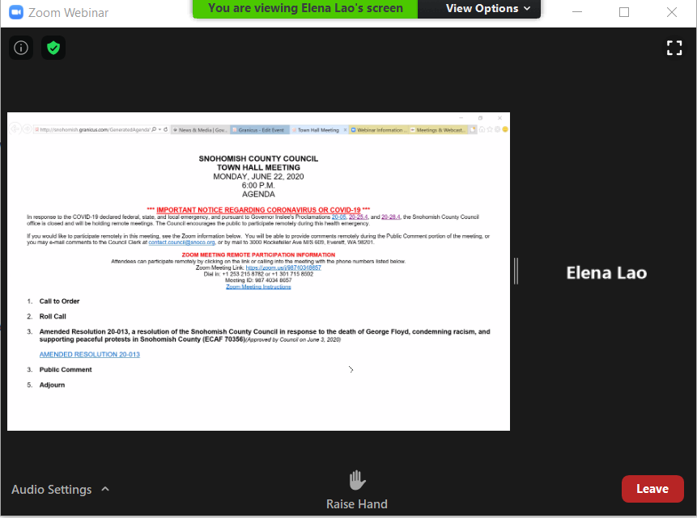

**Click RAISE HAND here**

1. The Chair will ask the clerk if any hands are raised.
2. Council staff will call on each ATTENDEE by the onscreen ID name, in the order that hands were raised, and “promote” ATTENDEE to PANELIST. As a PANELIST, you are able to turn on your video while providing public comment or testimony, if you choose to.

***(NOTE:*** *A black screen may flash on your computer screen during the transition in promoting an ATTENDEE to PANELIST. Please do not click on anything or leave the meeting and wait for the prompt from Council staff.)*

1. **Please wait for Council staff to announce that your audio is unmuted before speaking, and clearly state your NAME and CITY OF RESIDENCE for the record**.
2. All speakers will be limited to THREE MINUTES to provide comments or testimony.
3. When you are done speaking, Council staff will mute your audio, lower your hand, and “remove” you from the panel to continue participating as an ATTENDEE.

**BY PHONE:**

1. The Chair will announce and open Public Comment or Public Testimony.
2. As an ATTENDEE, you can virtually raise your hand by **pressing *9 on your phone**.
3. The Chair will ask the clerk if any hands are raised.
4. Council staff will call on each ATTENDEE by the last three digits of the phone number ID shown on the screen, in the order that hands were raised.
5. **Please wait for Council staff to announce that your audio is unmuted before speaking, and clearly state your NAME and CITY OF RESIDENCE for the record**.
6. All speakers will be limited to three minutes to provide comments or testimony.
7. When you are done speaking, Council staff will mute your audio and lower your hand.