**HOW TO “RAISE HAND” FOR PUBLIC TESTIMONY**

**PUBLIC TESTIMONY WILL BE OPENED FOR EACH PUBLIC HEARING AGENDA ITEM.**

**Please wait for the announcement that your audio is unmuted before speaking. Clearly state your NAME and AREA OF RESIDENCE for the record. All speakers are limited to THREE MINUTES.**

**To submit written comments, send email to:** [**Contact.Council@snoco.org**](mailto:Contact.Council@snoco.org)

**ONLINE:**

Click “**Raise Hand**” on the bottom of your Zoom screen.

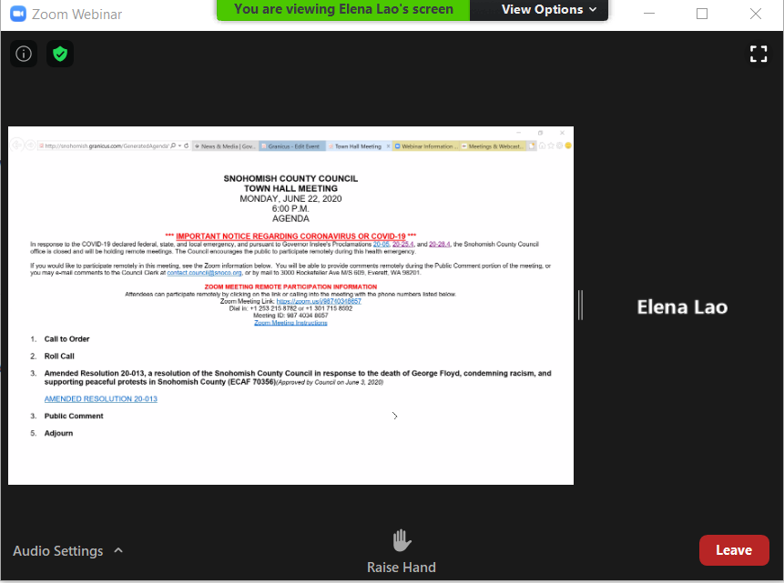

**Click RAISE HAND here**

**BY PHONE:**

**Press *9 on your phone to “raise hand”.**